Scheduling
Inquiry Slip

Patient Name Date
What is the best number to reach you?
Nature of Complaint
Where in your mouth is the (tooth, problem) located?
Is the area sensitive?  Yes  No Does hot or cold bother it?  Yes  No
Tell me how it feels.
Does it keep you up at night?  Yes  No Does it feel swollen?  Yes  No
Does it hurt to bite on it?  Yes  No
Is it a  sharp pain or a  dull, aching sensation?
Does this need to be taken care of  today or can it wait until  later?
When do you prefer to come in?  Right Now  Later Today  Tomorrow  Next Week
DO NOT ASK the patient this question, but note if the patient requested a prescription for pain:
❑ Yes  No Was a particular drug requested (which):
The office should try to get them in  Right Now  Later Today  Tomorrow  Next Week
I'm going to check with the doctor on this, so I need you to hold on.
Stop here and take to the Doctor:
32 17
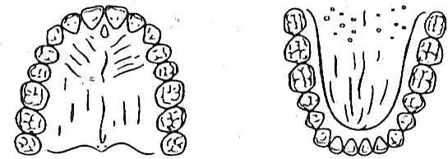
1 16
Right Upper Left Right Lower Left

Completed by Doctor:

Units  Of  Time | Priority | A+ A B C D R NR  50 40 30 20 10 00 | Estimated | Date
Units  Of  Time | Priority | A+ A B C D R NR  50 40 30 20 10 00 | FA | Time
ASAP
______D
______W
______NS

Scheduler tells the patient:
"I'm looking for an opening to work you into our schedule. The doctor wants to see you (when)." Work out the appointment for the patient and file this in the patient's chart.

Taken By
Copy Purple

Copyright © 2007-2015 Classic Practice Resources, Inc. All Rights Reserved

